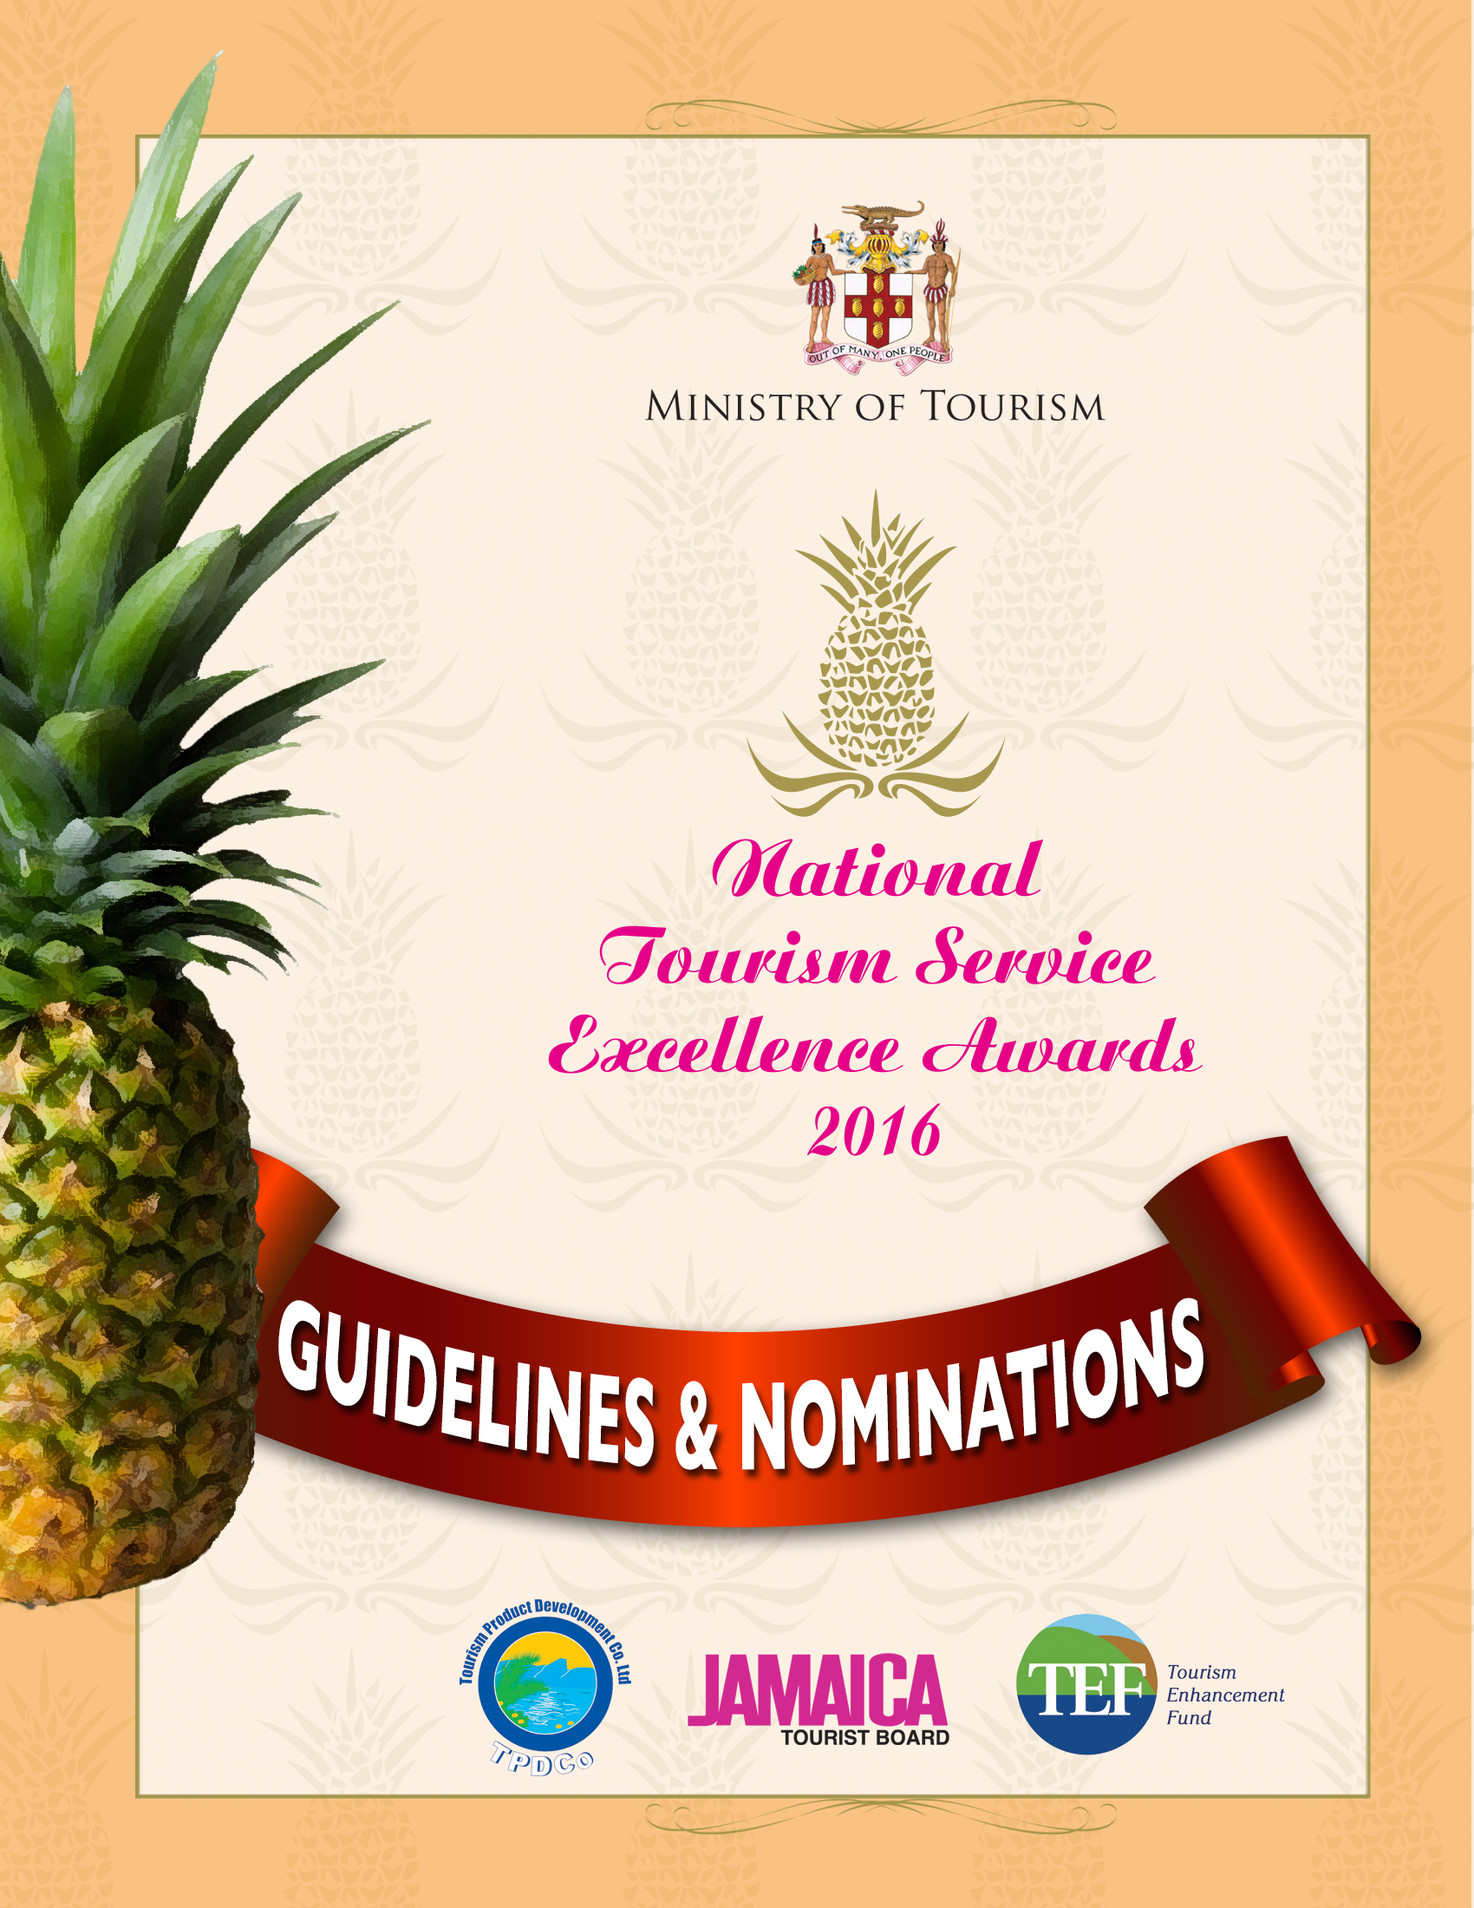

Contents

NOMINATION INFORMATION AND GUIDELINES 2
IMPORTANT DATES. 2
AWARDS OVERVIEW 2
Nomination process 4
Terms and Conditions 5
Nomination Forms 6
Individual Nomination Form 6
Organization Nomination Form 10

NOMINATION INFORMATION AND GUIDELINES

IMPORTANT DATES.
WEDNESDAY DECEMBER 28, 2016
Nomination period commences
FRIDAY JANUARY 27 2017 CLOSE OF NOMINATIONS
Closing date for nominations
Nominations will be accepted until 4:00pm local time

MONDAY JANUARY 30, 2017
Opening of nomination submissions

SATURDAY MARCH 4, 2017
Hosting of Awards

AWARDS OVERVIEW
Our vibrant tourism sector remains the main source of foreign exchange earnings for Jamaica and continues to fuel economic growth and development across the entire island. The Ministry of Tourism and its agencies remain committed to fostering the continued growth of the sector in a sustainable manner.
Excellent customer service delivery from every individual and entity is integral to the continued growth in the tourism sector. One of the most important components of the visitor experience is the quality of the interface between the visitor and the tourism worker, and their experience with tourism service providers. The National Tourism Service Excellence Awards is geared towards promoting performance excellence within the Sector
To this end, the Ministry of Tourism in recognition of individuals and organizations which have demonstrated best practices and offer excellent customer service will host the National Tourism Service Excellence Awards Ceremony on Saturday, March 4, 2017 in Montego Bay.
The major objectives of the National Tourism Service Excellence Awards are:
- To recognize & reward tourism entities that continually achieve sustained levels of excellence in customer service delivery.
- Recognize individual workers who continue to surpass normal customer service delivery standards.
- To select, showcase and award the Best in Service Excellence in order to establish internal benchmarks for all the categories of businesses in the Tourism sector.
- To evaluate the service being provided within the industry and serve as a mechanism to encourage tourism entities to improve customer service delivery

Nomination Forms
Nomination forms must be completed in full. Typed applications are preferred: Hand written nominations must be legible. Completed nomination forms must be signed and returned in original hard copy to a Tourism Product Development Company office listed below on or before the deadline. Receipts will be issued as proof of submission, FAXED OR E-MAILED NOMINATIONS WILL NOT BE ACCEPTED.
Nomination packages are available from the headquarters and regional offices of the Tourism Product Development Company and on line at http://www.tpdco.org
Nomination Booklets available Island-Wide
Tpdco Offices In
Kingston  The Tourism Centre 4th Floor  64-70 Knutsford Boulevard, Kingston 5  Tel: 968-3441: 968-1909: 968-3626- | Ocho Rios  Office #3  Ocean Village Shopping Centre  Main Street, Ocho Rios  Tel: 974-7705
Montego Bay  Block G  Montego Convention Centre  Montego Bay, St. James  Tel: 979-7987-8; 940-0374 | South Coast (Mandeville)  The Ashlar  Suite #5, 71 Manchester Road  Tel: 603-4782-3
NEGRIL
Negril Green Island Area Local Planning Authority (NGIALPA)
Norman Manley Boulevard, Negril
Office: 957-3962

Nomination process
Eligibility Criteria
Nominations for Individuals are based on the following:
- The nominee must be a full time employee who interfaces directly with visitors in a licensed tourism entity.
- Where the nominee is not directly employed in a licensed tourism entity, proof should be provided to verify their interaction with tourists and their positive impact on the tourism industry.
- Only if the person is self-employed are self-nominations permitted
- Persons employed to organizations are not allowed self-nominations; however nominees must agree to be nominated.
- Nominations should be based on individual’s career in the tourism industry with a minimum three (3) years with the same company
- Individuals nominated who have received Team Jamaica training will be given bonus points.

Nominations for Organizations/Businesses are based on the following:
- Organizations/businesses are allowed to nominate themselves.
- Organizations nominated must, interact with visitors and have an impact on the quality of the visitors’ experiences.
- Where applicable, organizations/businesses nominated must have valid a Jamaica Tourist Board License.

Nominations will be accepted from the following fields:
- Accommodation (properties and staff at properties including hotels, villas, apartments & guest houses),
- Attractions and Places of Interest (staff and business entities)
- Ground Transportation and Tour Operation (drivers, other staff and business entities)
- Craft markets/craft vendors
- Airport Staff
Red Cap Porters
Customs Officers
Immigration Officer

Terms and Conditions

- By submitting an entry into the National Tourism Service Excellence Awards, participants agree to be bound by the following terms and conditions: The closing date for receipt of entries
4pm Friday January 27, 2017
- Businesses can enter more than one category, but separate entry forms and supplementary information must be completed for each.
- Winners’ at the regional level automatically becomes a finalist at the national level.
- By entering the Awards, the entity/person agrees to be part of the publicity if you are a finalist in any category.
- The judges’ decisions are final and they cannot enter into discussion about the shortlisting process, choice of finalists or winners.
- In the event of any dispute regarding the awards criteria, application forms, judging process or any other matter relating to the awards, the decision of the panel of judges and organizing committee shall be final and no correspondence or discussion shall be entered into.

Organization Awards
Awards going to businesses/organizations will be issued both at the regional and national level:
1. Best Accommodation: Hotel/ Guest House/Villa/Apartment
This award is aimed at organizations classified as Accommodations, as stated in the Tourist Board Act 1955. There will be three (3) sub-awards in the Hotel category by virtue of the size of the business: Large – 100 rooms and up; Medium – 51 – 99 rooms; and Small – 10 – 50 rooms.
Villas, Apartment, Guest House.
2. Best Attraction
This award is targeted at businesses in the area of tourism attractions; which by industry standards are any type of natural or man-made entity that offers horticultural, cultural, historical, equestrian, aquatic or aerial activities for reward or profit.
3. Best Ground Transportation
This award is aimed at entities which provide local, on the ground transportation to tourists using motor vehicles, bikes, bicycles, buses, etc.
4. Best Water Sports Operator
This award is for tourism enterprises which offer water sports experiences to its customers.

Individual Awards
Provided enough entries are received from each resort area, each award listed below will be awarded at the regional and national level:
1. Best Craft Vendor
This award is for persons who offer goods for sale that are identified as indigenous craft produced locally.
2. Best Tour Operator
This award is for persons who display exceptional service in the area of organizing and arranging visits to places of interest which may involve the use of motor vehicles, bicycles, bikes and other modes of transportation.

3. Best Taxi Operator
This award is for taxi operators who transport tourists via a licensed operating company such as JUTA or as an independent - on a full-time or part-time basis. A significant portion of their daily activity must be transporting customers who are tourists.
4. Best Raft Captain
This award is limited to persons who provide tours to customers via rafting.
5. Best Attraction Employee
The award covers persons employed to venues that are classified as attractions by industry standards and offers tours and other activities as part of its overall visitor experience. Individuals will be judged on the overall quality of the experience they provide

Nomination Forms

Individual Nomination Form

Information for Applicant
Please indicate the area of the National Tourism Service Excellence Awards for which you are sending forward a nominee:

□ Accommodations

□ Craft Vendor

□ Tour Operator

□ Taxi Operator

□ Raft Captain

□ Attraction Employee

□ Airport Staff

Initial judging will be based on the information provided within the application form. All entrants shortlisted for National Awards will be informed

Information on Nominee
Please indicate the relevant tourism industry and other certification the nominee currently holds (please tick the applicable and appropriate boxes):

□ Team Jamaica Certificate
□ Food Handlers’ Permit (where applicable)
□ Other (please specify all other certifications,
___________________________________________________________________________
___________________________________________________________________________
___________________________________________________________________________
Please tick the type of supporting documents being submitted with this nomination:
□ copies of certificates, licenses or permits (specify each with expiry date )
□ testimonial letters – (minimum of 2, maximum of 4 persons)
□ photographs/slides/videos
□ articles/ brochures
□ copies of awards/citations
□ other (please specify): ______________________________________________

Nominee Details (Individual being nominated):
Title: □ Mr. □ Ms. □ Mrs. □ Other:_____________
Full Name:___________________________________________________________________________
Post/ Title:___________________________________________________________________________
Organization/ Business Name:___________________________________________________________
Type of tourism organization:____________________________________________________________
Address:____________________________________________________________________________
Email Address:_______________________________________________________________________
Contact Name and Position:_____________________________________________________________
Telephone Number:____________________________________________________________________
Resort area: □ Montego Bay □ Ocho Rios □ Negril □ Kingston □ South Coast □ Port Antonio

Section 1: Customer Service
Please give examples of how the individual ensures that the highest quality experience and outstanding customer service is provided to visitors. (max 300 words)
Guide to Response
In your answer consider the following:
- Speak to individual’s attitude toward customers (e.g., poise, charm & courtesy)
- Shows initiative, going above and beyond the call of duty when dealing with customers
Describe in detail how as a team member the nominee strives to work with peers and supervisors to build team spirit, solve problems and contributes generally to the improvement of the work environment (250 words).
Guide to Response
In your answer consider the following:
- Speak to individual’s attitude toward coworkers (e.g.. team spirit & respect for authority)

On a scale of 1 to 5, with 1 being the lowest and 5 being the highest, how would you rate the individual’s general deportment (poise, personality, courtesy, charm)

1 2 3 4 5

Section 2: Capacity Building
Please give details of any job sector knowledge and skills improvement programmes taken by the nominee (250 words).
Section 3: Creativity & Innovation
Please give examples of how the individual has created or contributed significantly to any innovative service or product that has improved the business (250 words)
Guide to Response:
In your answer consider the following:
- Any ‘first-of-the-kind’ or pioneering service or product influenced by the nominee
- Willingness to make suggestions
Section 3: Standards
Describe how the individual’s performance meets industry and internal quality and operating standards (250 words).
Guide to Response
In your answer think about the following:
- Nominee’s compliance with all applicable certification, safety environment
Section 4: Sustainability
Outline the contributions the individual makes toward community conservation and sustainability and in and out of their work environment (250 words).
Guide to Response
In your answer consider the following:
- Show how the individual is engaged in or contributes to effective environmental management practices (e.g.. energy, water)
- Outline how the individual promotes environmental awareness through an active process among clients, staff and community

END OF INDIVIDUAL APPLICATION FORM

Organization Nomination Form

Information for Applicants
Please indicate the area of the National Tourism Service Excellence Awards for which you are applying:

Accommodation : Hotel: □Large (100 rooms & up) □Medium (51-99 rooms)□Small (10 – 50 rooms)
Other accommodation : □ Guest House □ Villa □ Apartment

□ Attraction

□ Ground Transportation

□ Water Sports Operator

Initial judging will be based on the information provided within the application form along with your website and other information sources. Approximately three businesses will be shortlisted from each resort area for each category. Short listed businesses will be visited. All entrants shortlisted for National Awards will be informed.

Nominee Information (Organization/Business being nominated)
Business Name:________________________________________________________________
Address:______________________________________________________________________
Telephone number:_____________________________________________________________
Email:________________________________________________________________________
Website address:_______________________________________________________________
Facebook:_____________________________________________________________________
Twitter:_______________________________________________________________________
Other social media:______________________________________________________________
Contact Name and Position:_______________________________________________________
Public Relations Contact (if different):________________________________________________
Resort area:□ Montego Bay□ Ocho Rios □ Negril □ Kingston □ South Coast □ Port Antonio
Number of persons employed to organization: Full time _________ Part time_________

Organization/Business Details
Organization/Business Details

Please indicate the relevant tourism industry and other standards and regulations your organization currently holds (please tick the applicable and appropriate boxes and state expiry dates ):

□ Jamaica Tourist Board License
□ Team Jamaica Participating entities (state percentage of staff certified) _____
□ Public Health Certificate
□ Food Handlers’ Permit (Where applicable)
□ Fire Safety Certification
□ Public Liability Insurance (give examples)
□ Other (please specify all required certifications, e.g.. swimming pool permit)
___________________________________________________________________________
___________________________________________________________________________
___________________________________________________________________________

Please tick the type of supporting materials being submitted with this nomination:
□ copies of certificates, licenses or permits
□ testimonial letters – (minimum of 2, maximum of 4 persons)
□ photographs/slides/videos
□ articles/ brochures
□ copies of awards/citations
□ other (please specify): ______________________________________________

Section 1: Customer Service

Please describe how your organization provides exceptional service with respect to your specific type of business. (max 300 words)
Guide to Response
In your answer consider the following:
- Customer care and welcome (for e.g.. how your organization deals with bookings and complaints)
- Facilities and services provided
- How your organization differentiate itself from others in the industry
Section 1: Accessibility
Briefly outline ways in which the organization caters to the needs of special groups (for e.g. children, elderly, persons with special needs, foreign language speakers etc.) (max 250 words)
Guide to Response
In your answer consider the following:
- Changes implemented by your organization to cater to the needs of these groups
- Give examples of how your organization looks after guests who speak a foreign language and persons with special needs
- How you inform and promote the accessibility of the organization’s premises
Section 3: Staff Training and Development
Please give details of staff training and development activities during the past two (2) years (max 200 words)
Guide to Response
In your answer consider the following:
- Total number of staff trained and areas of training
- Types of training you/your staff have attended
- How your staff remain motivated and feel part of the team
Section 3: Marketing and Innovation
Please describe your target market and explain briefly how you attract new and repeat business, including any innovative promotional campaigns and what impact they have had. (max 250 words)
Guide to Response
In your answer think about the following:
- Your marketing plan, marketing materials- promotional campaigns, online marketing activity
- How you engage with your customers and social media online e.g. replying to TripAdvisor ratings
Section 4: Sustainability
In no more than 250 words, give a description of the initiatives or ‘responsible’ operations of the organization.
Guide to Response
In your answer consider the following:
- How you encourage guests and employees to act in responsible manner and how you promote this
- How you support your local economy, e.g.. buying local produce, services, suppliers, employment, Corporate social responsible (CSR) initiatives
- Environment - managing water, energy and reducing waste

END OF ORGANISATION APPLICATION FORM

